**Constant Cross Section Fin**

ME 436 Aerothermal Fluids Laboratory

Jeremy Maniago

Experiment #3

11/27/2023

Mechanical Engineering Dept.

The City College of New York, USA

# Abstract

|  |  |  |
| --- | --- | --- |
|  | $${q"}_{o}=\frac{V^{2}}{A_{c}R}$$ | (1) |

In this experiment, we investigate the effects of high heat transfer rates. Fins are commonly used to improve cooling by utilizing an increase in the rate of heat transfer. Fins usually have a small thickness and are long relative to this thickness and are made of highly conductive materials which make its Biot number small. The goal of this experiment is to find the unsteady and steady state temperature distributions along a fin and to make comparisons with theoretical calculations. The total heat transfer loss will also be calculated. The experimental setup uses a cylindrical copper fin being electrically heated at its base. Temperature measurements are taken from nine Type J thermocouples distributed along the length of the fin. The results suggest a general trend to converge to a steady state with a decreasing temperature distribution as we go along the length of the fin from the base similar to that of theoretical predictions. However, there are many uncertainties that vary the transient and steady state temperatures due to uncontrollable factors such as convection outside of the fin, deteriorating material, inaccurate measurements due to faulty equipment, etc.

# Introduction

Extended surfaces, or fins, are common in cooling applications for heated surfaces. Fins are characterized by their thin and elongated shape and are usually made of highly conductive materials. Its high conductivity makes its Biot number, a dimensionless parameter, low in that it enables simplification of the analysis of the fin. This simplification reduces the problem in that the fin temperatures only varies along the length of the fin and not in the transverse (radial) direction.

Since we want to find the theoretical steady and transient temperature distributions along the fin, the experimental heat transfer coefficient is based on the experimental data. Using equation below, and knowing $q_{loss}$ based on measured values, we can solve for the experimental heat transfer coefficient ${\overline{h}}_{exp}$

|  |  |  |
| --- | --- | --- |
|  | $$q_{loss}={\overline{h}}_{exp}\int_{0}^{L}{\left(T_{ss}\left(x\right)-T_{amb}\right)C}dx$$ | (2) |

Where L is the length of the fin (605mm) and the location of the last thermocouple, $T_{ss}\left(x\right)$ is the steady state temperatures of each thermocouple, $T_{amb}$ is the ambient temperature (thermocouple 8), and C is the circumference of the fin (fin diameter is 12mm). Using the experimental heat transfer coefficient value, we can then calculate the theoretical temperature distribution using the equation

|  |  |  |
| --- | --- | --- |
|  |  | (3) |

Where ${q"}_{o}$ is the power of the heater per unit area, *k* is the thermal conductivity of copper (401 W/m*K), $α$ is the thermal diffusivity of copper, *t* is the time (seconds), and *n* is a counter. ${q"}_{o}$ is given by the equation:

Where V is the supply voltage (40W), R is the heater resistance (178Ω), and $A_{c}$ is the cross-sectional area of the fin. *m* is given by the equation:

|  |  |  |
| --- | --- | --- |
|  | $$m=\sqrt{\frac{hC}{kA_{c}}}$$ | (4) |

Where *h* is the convective heat transfer coefficient. $α$ is given by the equation:

|  |  |  |
| --- | --- | --- |
|  | $$α=\frac{k}{ρC_{p}}$$ | (5) |

Where $ρ$ for copper is 8960 kg/m­3 and is the specific heat for copper (386 J/kg*K).

# Experimental Setup and Procedure

First, set the variac position to zero. All thermocouples and electrical contacts should be secured in place before turning the power supply on. After these checks are done, turn on the computer and start the Data Acquisition software, choose a sampling frequency of 1Hz, and choose the total sampling duration of 30 minutes. Next, turn on the power and increase the power supply to about 15 volts by using the multimeter to measure the exact voltage settings. Plug in the power to begin heating the fin, and simultaneously start the data acquisition. After the data is taken, save it as a text file. After, use a fan to cool down the fin before repeating measurements for higher voltage settings, up to a maximum of 40 volts. After all measurements at all voltages are complete, turn off the power at the variac.

# Results

The results from our experimental measurements show a reasonable temperature distribution along the length of the fin, that being highest at the base where the fin is being heated and lowest at the tip of the fin and ambient temperature at the last thermocouple. Figure 1 shows the experimental and theoretical steady state temperatures for all of the thermocouples. The experimental steady state temperatures along the length of the fin follow the expected downward trend along the fin, similar to that for the theoretical steady state values although not as smooth due to a limited number of thermocouples at shorter *x* intervals along the fin. Figure 2 shows the transient state temperatures for the experimental and theoretical values. The theoretical values plotted correspond to the *x* position of the thermocouples. The trends of the plots over time are similar for the experimental and theoretical values, but the spread and max temperatures start to vary greatly when getting closer to the base of the fin. Figure 3 has error bars plotted on the experimental steady state temperature values and at the data point having a large dip, the uncertainty is the highest.

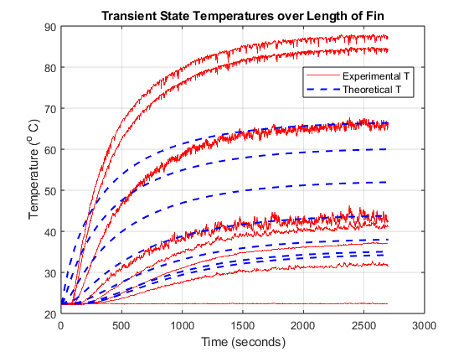

Figure 2: Transient State temperatures for experimental and theoretical values

# Conclusions

In conclusion, the experiment proved to be successful in showing the uses of fins for cooling. The steady state temperatures were expected to decrease over the length of the fin, which further confirms the effect fins have on cooling. However, the experimental values in transient state, or over time until steady state, had a steeper slope into the steady state temperature. This trend is more pronounced for measurements taken closer to the base of the fin. This may be due to small transverse heat effects that were ignored for simplification, or the fact that other factors like convection in the perturbed air around the fin can affect the temperature distribution over time. For better results, it would be better to place the fin inside either a vacuum or a controlled temperature chamber to minimize environmental effect on the fin, further isolating the heat transfer along the material of the fin.

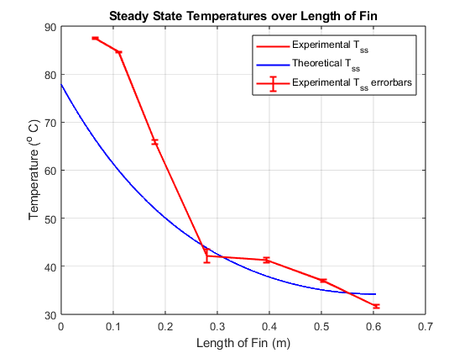

Figure 3: Error bars for experimental steady state temperatures

# List of References

[1] Goushcha, Oleg. *Aero-Thermal-Fluids Laboratory ME 43600 Manual*, Blackboard, 2019

# Appendix A

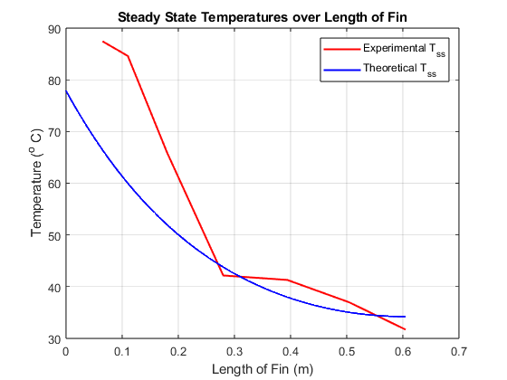

Figure 1: Steady State temperatures for experimental and theoretical values

# Appendix B

# Appendix D

clc

clear

close all

set(0,'DefaultFigureWindowStyle','docked')

tc = [65, 110, 180, 280, 394, 504, 605]; % mm

tc = tc ./ 1000; % m

L = tc(end); % m

d = 12/1000; % m

V = 40; % Volts

R = 178; % Ohms

A = pi()*((d/2)^2); % m^2

q_flux = (V^2)/(R*A);

q = q_flux * A; % W/m^2

%% 0 | Data

clear data fin

data = readmatrix('FinData.txt', 'NumHeaderLines', 2);

fin.t = data(:,1);

for i = 1 : size(data, 2) - 1

fin(i).ch = data(:,i+1);

end

%% 1 | Experimental Heat Transfer Coefficient

T_amb = fin(8).ch(end);

for i = 1 : size(fin,2) - 1

T_ss(i) = fin(i).ch(end);

end

C = d*pi();

integral = trapz(tc, T_ss - T_amb)

hbar_exp = q / (integral*C)

%% 2 | Theoretical Temperature

k = 401; % W/m*K

m = sqrt((hbar_exp*C)/(k*A));

rho = 8960; % Copper, kg/m^3

Cp = 386; % Copper, J/kg*K

alph = k/(rho*Cp);

th.t = fin(1).t; % seconds

th.x(:, 1) = 0: 0.0005: L;

th.T = zeros(size(th.x, 1), size(th.t, 1))

for i = 1 : size(th.x, 1)

for j = 1 : size(th.t, 1)

summ = zeros(100, 1);

for n = 1:100

summ(n) = (cos(n*pi()*th.x(i)/L)*exp((-n^2)*(pi()^2)*alph*th.t(j)/(L^2)))/((m^2)*(L^2)+(n^2)*(pi()^2));

end

summ = sum(summ);

one = (exp(m*(th.x(i) - 2*L)) + exp(-m*th.x(i)))/(m*(1 - exp(-2*m*L)));

two = -2*exp(alph*th.t(j)*(-m^2));

three = 1/(2*(m^2)*L) + L*summ;

th.T(i,j) = T_amb + (q_flux/k)*(one + (two*three));

end

end

th.T = th.T .'

%% 3 | Plot steady state temperatures

clf

fig1 = figure('Name','Steady State');

plot(tc, T_ss, LineWidth = 1.5, Color="r")

hold on

th.ss = th.T(end, :);

plot(th.x, th.ss, LineWidth = 1.5, Color="b")

grid on

title('Steady State Temperatures over Length of Fin')

xlabel('Length of Fin (m)')

ylabel('Temperature (^o C)')

legend('Experimental T_{ss}', 'Theoretical T_{ss}')

ax1 = gca;

%% 4 | Plot transient state temperatures

fig2 = figure('Name','Transient State');

exp_plot = plot(fin(1).t, [fin.ch], LineWidth = 0.1, Color="r");

hold on

th.ss = th.T(:, end);

th.x_real = find(ismember(th.x, tc));

th_plot = plot(th.t, th.T(:, th.x_real), LineWidth = 1.5, Color="b", LineStyle="--");

grid on

title('Transient State Temperatures over Length of Fin')

xlabel('Time (seconds)')

ylabel('Temperature (^o C)')

legend([exp_plot(1), th_plot(1)], {'Experimental T', 'Theoretical T'})

legend("Position", [0.64702,0.72579,0.23571,0.082143])

ax2 = gca;

%% 5 | Uncertainty

clear udata u

udata = readmatrix('Uncertainty.txt', 'NumHeaderLines', 2);

u.t = udata(:,1);

for i = 1 : size(udata, 2) - 1

u(i).ch = udata(:,i+1);

u_ss(i) = mean(u(i).ch(:, 1));

end

err = (u_ss(1:7) - T_ss)/2;

errorbar(ax1, tc, T_ss, err, 'DisplayName', 'Experimental T_{ss} errorbars', LineWidth = 1.5, Color="r")